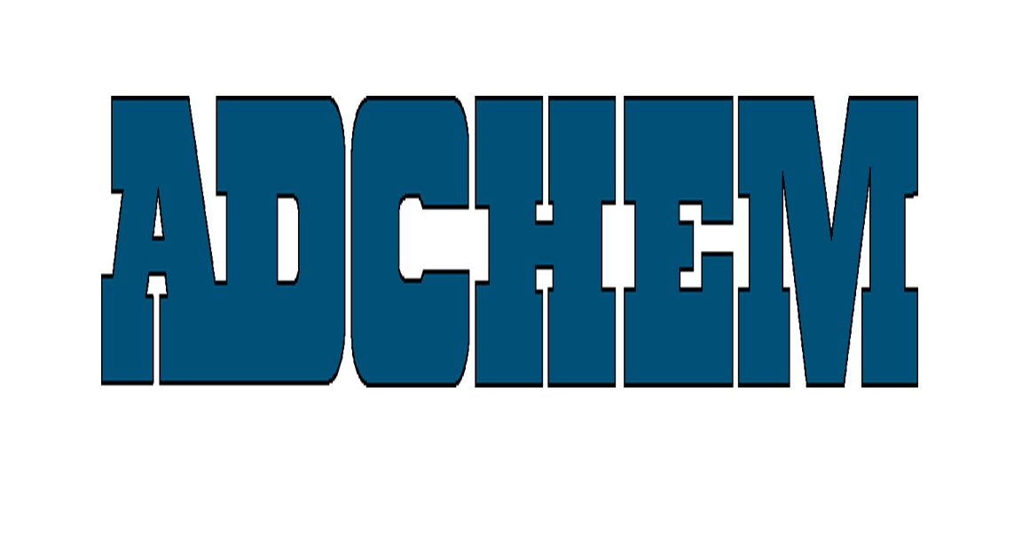

For Immediate Release:

Adchem Introduces New 353M Double-Coated Acrylic Adhesive Tape

Formaldehyde-Free Pressure Sensitive Tape Composition

Adchem Corporation, a leading manufacturer of innovative, pressure-sensitive adhesive tape systems, introduces its new 353M Double-Coated Acrylic Adhesive Tape System. 353M is formaldehyde-free and combines the quick-stick properties of rubber-based systems with the temperature performance of acrylic systems. Engineered for a wide-range of industrial tapes for substrate-bonding applications, 353M is ideal for low surface energy materials and foams such as cross-linked polyethylene, low perms, ethers and esters.

Part of Adchem’s new 300 Adhesive Series, 353M maximizes performance and optimizes economics by incorporating a differential caliper coating of 1.7 mils on the exposed side and 1.3 mils on the liner side and typical peel values of 72 oz. per inch width on the exposed side and 64 oz. per inch on the wide on the liner side. Several liner options are available including 55 lb. densified Kraft, 74 lb. polycoated paper, 12 point board and a 2-mil PET liner.

About Adchem Corporation
Adchem, an ISO 9001 certified and A2LA accredited company, manufactures an innovative line of pressure-sensitive adhesive tape systems, including double-coated papers, films, tissues, foams and fabrics; transfer tapes; one-side coated products and other custom-coated specialty products. Our 100% solids adhesives, solvent and water based acrylics and rubber adhesives are used in a variety of industries, including automotive, construction, electronics, graphic arts, medical and general industrial tape applications.
For additional information and samples, please contact Adchem Corporation, 1852 Old Country Road, Riverhead, NY 11901 Phone: (631) 727-6000 Fax: (631) 727-6010 or our website at www.adchem.com .

